Project Design Phase-I Problem Solution Fit

|  |  |
| --- | --- |
| Date | 18 October 2022 |
| Team ID | PNT2022TMID31048 |
| Project Name | Personal Assistance for Seniors Who Are Self-Reliant |

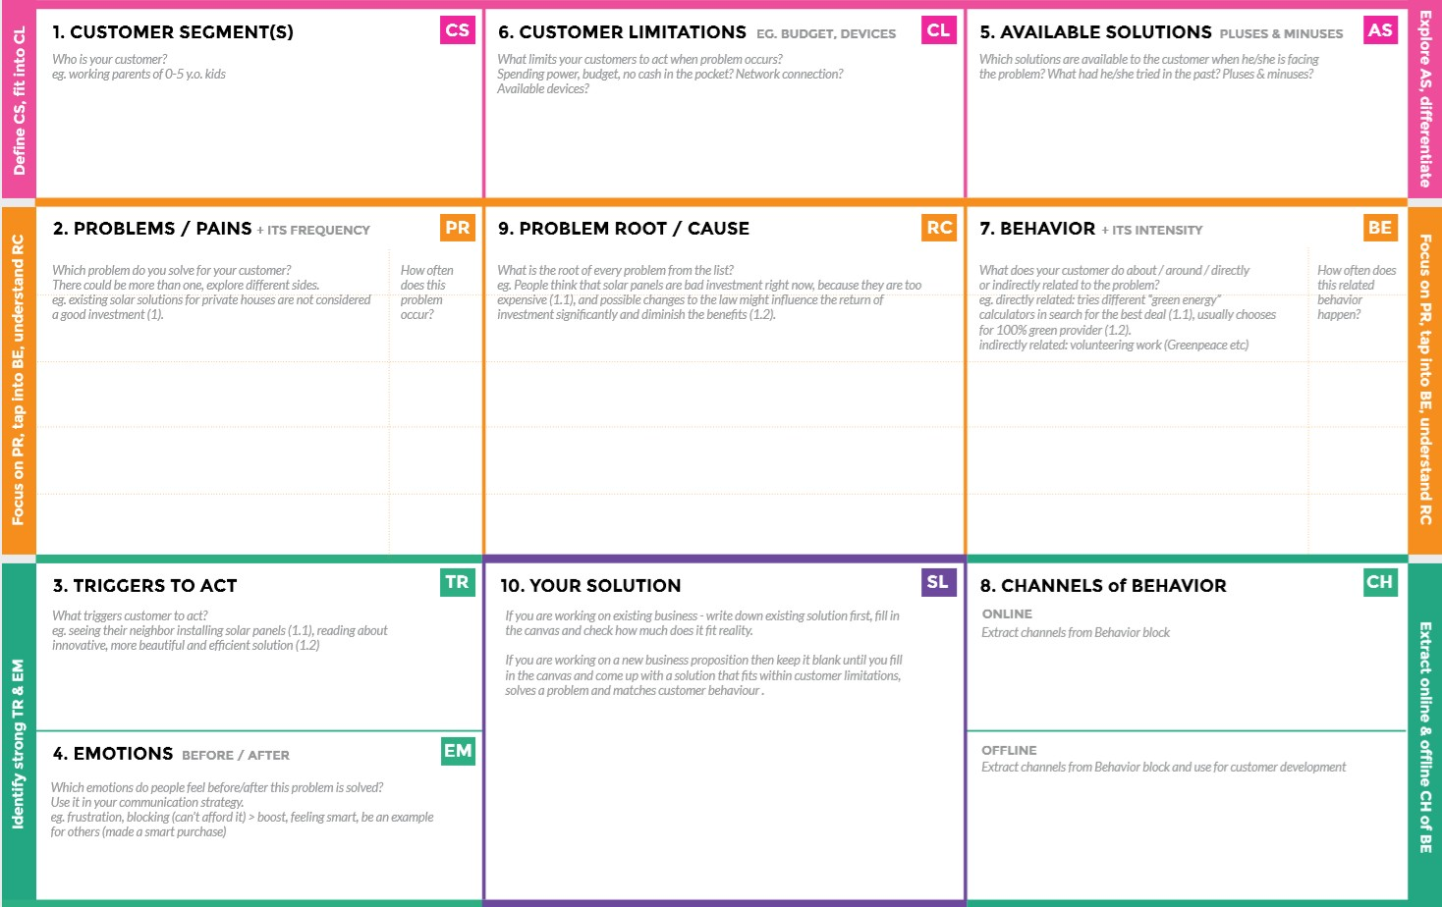

* Before ages there are peoples who are appointed to remind them by taking medicines at the time.
* By forgetting their medicines they risk their life in danger.

By this applications they can be relaxed by taking their medicines/drugs at correct time and correct medicine.

Efficient/valuable cost for their intake in medicines by reminding their medicines.

**Before:** They risk their life by taking different medicines/drugs.

**After:** increase their confidence by reminding their medicines.

Through newspaper advertisements.

Promoting through social media. With the help of social media entrepreneurs/influencer.

To develop an application that reminds their medicine at the time.

This may leads to a wrong/other intake medicine/drugs that may cause several diseases.

When the Elders/Patients forgot to take their medicine/drugs at the time that causes severe damage in their internal organs and their body.

* Elders who are suffering to identify their daily medicines, due to their carelessness.
* Patients who are risk to remember their medicines/drugs.

Seniors who are forgot to take their medicines/drugs at the time.